**UNIT 3: Services**

1. Website **reviews**
2. Explaining how something works.
3. Comparison and contrast.
4. Grammar: adjectives/adverbs; phrasal verbs
5. Task: Explaining how something works.

**Service systems**

* delivery of products and services
* configuration of technology and networks designed to deliver services that satisfy the needs, wants, or aspirations of customers

1. **Website reviews**

More than 88% of online shoppers incorporate reviews into their **(adquisiciones)** decisions. Businesses are told to get more reviews on review websites to keep attracting new **clientes**. And, as consumers, we are asked to leave a review for almost every transaction we complete.

Business reviews help shape a company's online reputation. In fact, one of the worst things a business can do is ignore their online reviews and social posts.

Business reviews provide valuable (**retroalimentacion)** for businesses. While it can be easy for a company to **take** negative comments **to heart**, it is important to recognize that reviews are constructive feedback. All in all, reviews are actually valuable feedback! They help a company measure their **(rendimiento)** and see how they can **(mejorar)**. **There is** always **room** for improvement and a lot can be learned even from positive business reviews.

Through reviews, businesses can see which products or services they should **(presumir/alardear)** and which needs work.

**Read these websites reviews:**

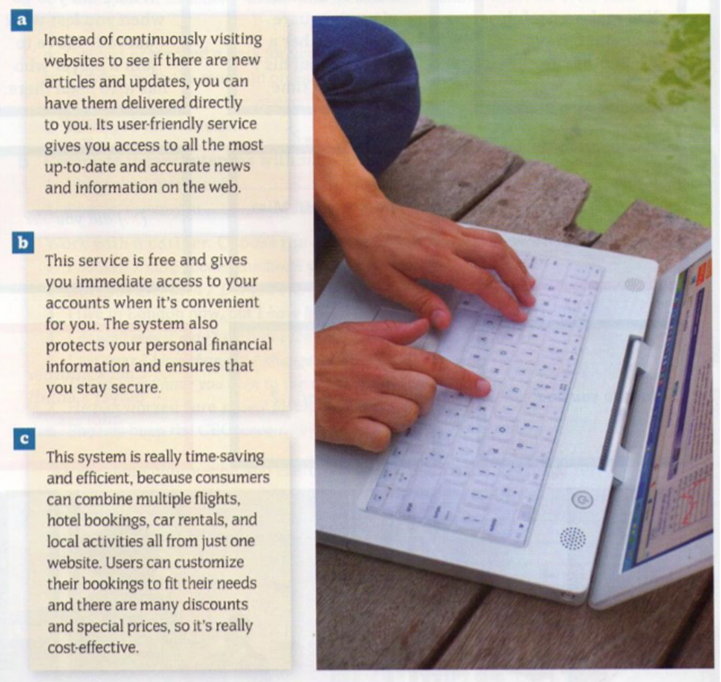

What kind of website is each extract about?

[Which are the best review sites and why?](https://www.quora.com/Which-are-the-best-review-sites-and-why)

**Describe these sites using verbs like: help, allow, let, make it easier for…(with or without “to”):**





Computer & tech, Accommodation, booking, Jobs, Destinations: flights, hotels, etc.

Movies, Car reviews, Restaurants, Games, Photos, Music and video

<https://learnenglishteens.britishcouncil.org/skills/writing/intermediate-b1-writing/website-review>

1. **Explaining how something works**

- Comparing and contrasting: _____________________________

- Describing what something does or how it works: ____________________

|  |  |
| --- | --- |
| 1. The good news is…..  2. It might seem a bit difficult to use at first…  3. Looks very similar to…  4. The more…  5. On the one hand… | but the bad news is  but in fact it is very simple  but what’s different is…  the (comparative)…  but on the other hand… |

**Compare the functionality of the objects, systems, or services below. Talk about benefits and drawbacks of each of the objects/systems:**

Iphone/ android

Online classes/traditional classes

Low cost flights/company flights

**PRESENTING /EXPLAINING HOW SOMETHING WORKS**

Why do companies have a database?

What sort of information do they keep?

Do you use databases? If you do, is the system easy to use?

**Explaining how something works: written explanation:**

* put the steps of the process/items in the proper order
* Each paragraph should have one main idea
* Use transition words that show how the steps of the process are related to one another: first/initially, second, next, after, later, while, finally.
* Give information clearly.
* Teach the reader something.
* Tell what, who, why, or how to do something.

**Finding a topic:**

Write a list of anything you know about:

* Your hobbies
* Things you’ve studied
* Jobs you’ve had

Choose the top three that interest you, and try to think how much you can write about each.

**Ideas for topics:**

1. How to use Google Maps.
2. How to set up a website.
3. How does Javascript work?
4. What is a cookie?
5. How to customize your car.
6. How to start a small business.
7. How to use eBay/vinted to sell things.
8. How to take better photographs.
9. How to learn a foreign language.
10. How to pack boxes for moving.
11. What is virtual reality

***“If you can’t explain it simply, you don’t understand it well enough.”***

***Albert Einstein***

**5 Tips to Improve Giving Explanations**

Tip1: Focus on making your thinking clear.

Tip 2: Try and write what you want to explain.

Tip 3: Pay attention to your listener.

Tip 4: Tell a story or give examples to make things easier to understand.

Tips 5: Write it down and check on it.

**Adverbs**

Adverbs of manner

-usually formed from [**adjectives**](https://learnenglish.britishcouncil.org/english-grammar-reference/adjectives) by **adding *–ly***:

|  |  |  |
| --- | --- | --- |
| *bad* > ***badly*** | *quiet* > ***quietly*** | *sudden* > ***suddenly*** |

but sometimes there are changes in spelling:

|  |  |  |
| --- | --- | --- |
| *easy* > ***easily*** | *gentle* > ***gently*** | *careful* > ***carefully*** |

The adverb formed from *good* is *well*:

*You speak English very****well****.*

Adverbs of manner normally come [after the verb](https://learnenglish.britishcouncil.org/node/1306/):

*He spoke****angrily****.*

or after the object:

*He opened the door****quietly****.*

If an adjective already ends in -ly, we use the phrase ***in a …. way*** to express manner:

silly: He behaved ***in a silly way***.friendly: She spoke ***in a friendly way***.

A few adverbs of manner have **the same form as the adjective**:

They all worked ***hard***.She usually arrives ***late/early***.I hate driving ***fast***.

hardly and lately have different meanings from hard and late:  
 He could***hardly***walk. = It was **difficult** for him to walk.  
 I haven't seen John ***lately***. = I haven't seen John **recently**.

<https://learnenglish.britishcouncil.org/english-grammar-reference/adverbials-of-manner>

Adverbs of frequency: often, sometimes, never…

*Hardly ever, now and then, seldom*

**Adjectives**

**High and tall**

What is high and what is tall?

**Tall**:  if a thing is higher than it is wide, then we use *tall*: people, trees, ladders, street lamps, buildings with a lot of floors are*tall:*

*This forest has very tall trees.*

*I am 1,70 cm tall.*

**High:** we use *high* for things which are wider:

*There are some high mountains in Austria.*

*Prisons have very high walls.*

When talking about measurements, **Tall**is used for people and **High**for things. There are things that can be “tall” or “high” depending on the context:

*I am 1,70 cm tall*

*This building is 25 m high / I live in a very tall building*

The adjective **High** is used when talking about distance above the ground:

*The shelf is too high for me to reach. Can you help me?*

The clouds are very **high** today

This park has very **tall** trees

The woman is six feet **tall.**

What is the **highest** mountain in the world?

This building is 75 metres **high.**

This is a very **tall** building. It has 30 floors.

The fence was too **high** for a man of his age to climb

Complete the text with suitable adverbs. Use the adjectives in the box to make adverbs.

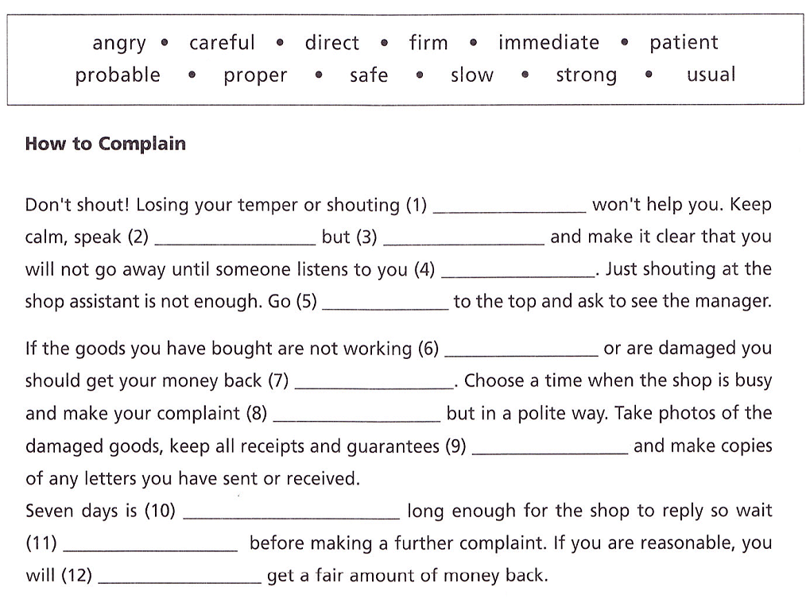

**Correct the mistakes in this text:**

Sometimes I wonder what people in other countries think about us. We are no longer among the rich and powerfuls of Europe. In a very short period, we seem to have turned into the poor and weaks. The situation is appalled. You cannot walk down a street in our cities without seeing a homeless. The unemployed stand around on our street corners. The old and sick receives no help. Why are we no longer shocking that this is going on? It is like this everywhere? Does the Japanese and the Canadian have the same problems? I doubt it. The unthinkable have happened here and we must do something about it soon.